**HOSPITAL ANALYSIS**

Even though SQL isn't primarily designed for creating visual charts, we were able to make a histogram using the "Time in Hospital" data. This helped us understand how long patients usually stay. After looking at the results, we found that the majority of patients stay for 7 days or less. Specifically, we noticed that the highest number of patients stayed for only 3 days before they were discharged.

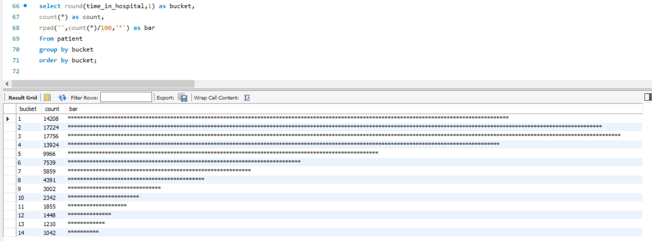

For a business to do well, it's crucial to know what services it offers so that it can plan effectively. In our case, we wanted to figure out the different types of medical services the hospital provides. To do this, we sorted them based on their medical specialty. However, since the initial list only gave us a long list of specialties, we needed to use more commands to get a better and clearer understanding.

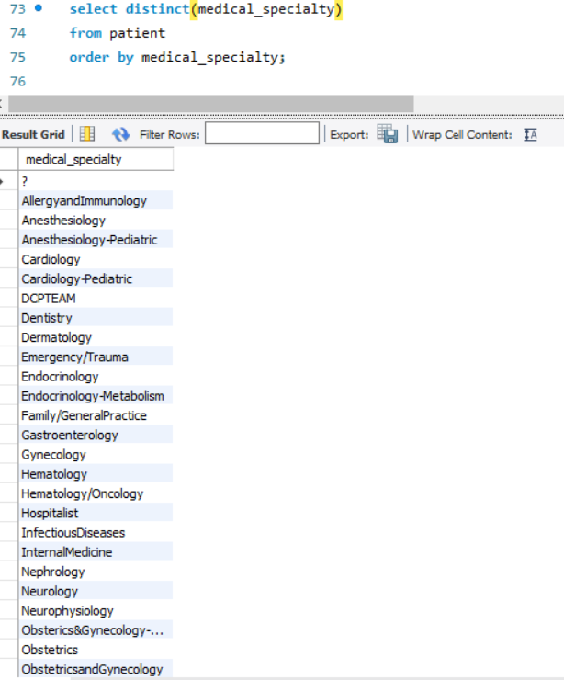

By using the "HAVING" and "ROUND" commands, we improved our understanding of those particular medical specialties. To dig even deeper, we specifically looked for medical specialties with an average greater than 2.5 and a count exceeding 50. Based on the results, we found that "Surgery-Thoracic" had the highest average number of procedures among all the medical specialties.

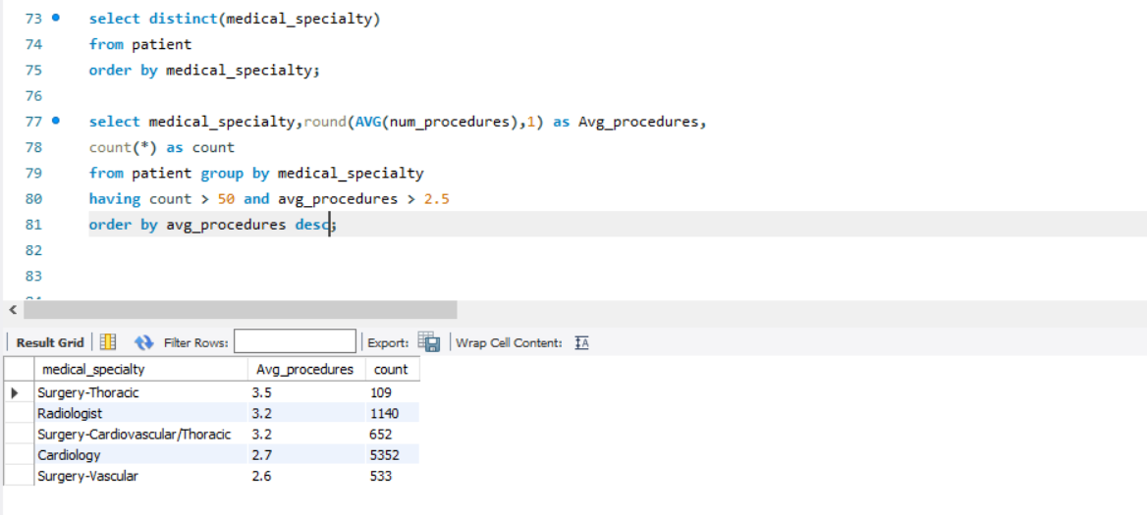

After analysing the patient data, our next goal was to inform our boss about the race with the highest average number of lab procedures. We used a command to calculate the average of "Number of Lab Procedures" for each race in the dataset and arranged them in descending order based on this average. The findings led us to the conclusion that African Americans have the highest average number of lab procedures among the different races.

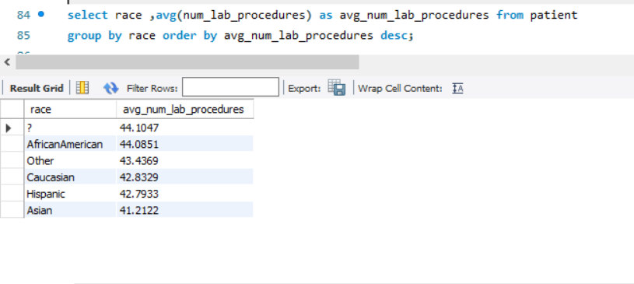

Next we took on the Command "UNION" this allows us to add rows together from two different data sets. The command below we created a UNION where the race was African American and UP in the patient table. The results below are not fancy, but it outlines the Patient Numbers for African Americans.

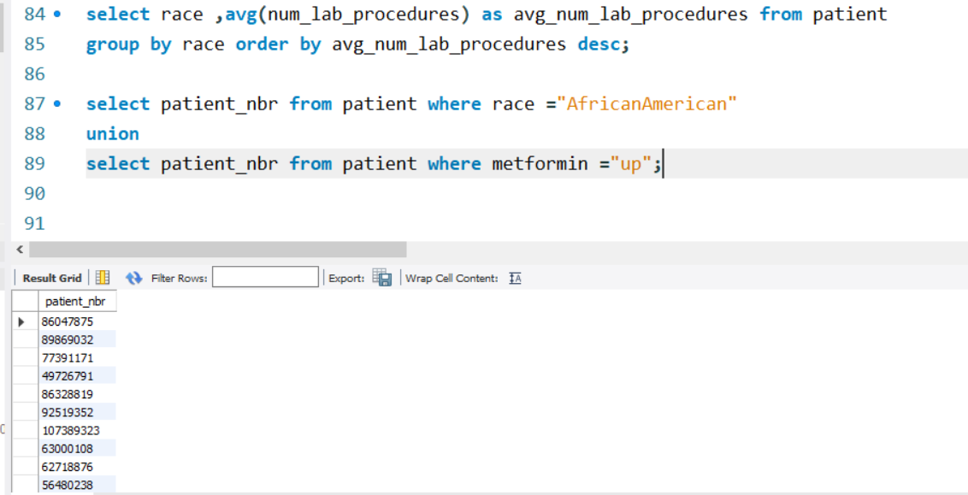

Similar to our previous analysis with "HAVING," we examined the average number of procedures based on medical specialties. The difference this time is that we considered all results without filtering for counts greater than 50 and average procedures greater than 2.5. In these results, we found that Proctology had the highest average number of procedures, which was 4. However, it's essential to note that this high average is based on only one occurrence.

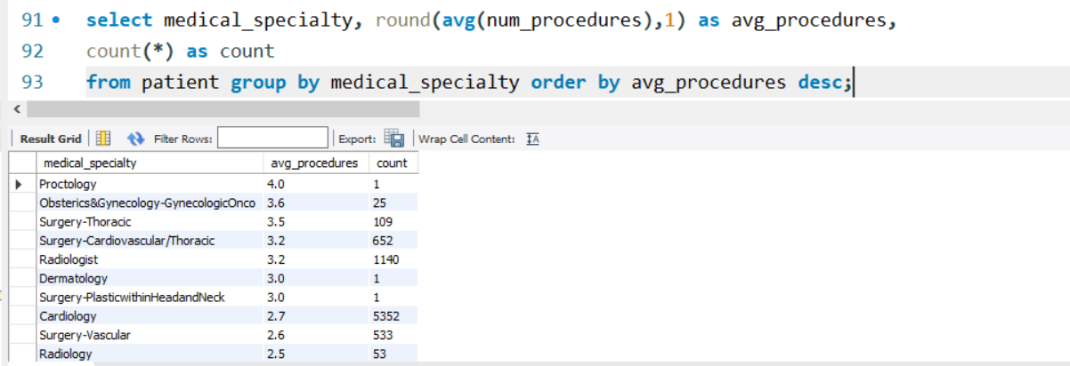

Our boss requested a list of patients who had been readmitted, along with the count of medications and lab procedures they had. To streamline this task, we utilized the "CONCAT" function, which enables us to combine text in our string to present the information as a sentence. In the command below, we used the Patient_nbr from the patient dataset to retrieve our data. After that, we determined the number of medications and lab procedures so that we could include this information in our Concat statement. Additionally, we used INNER JOIN to ensure a smooth and connected process. We set a limit of 50 to manage the output efficiently.

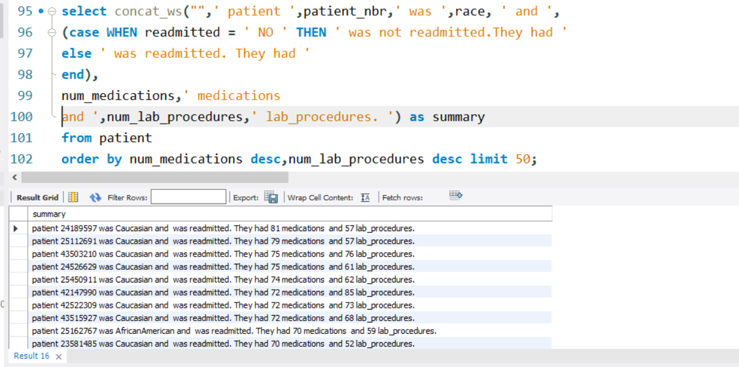

From the results above you can see each line has the Patient Number what their race is and whether they were readmitted. Then it shows how many medications they have and the number of lab procedures performed for them. This will help our boss present the facts when determining how to best help the hospital.

We used a Subquery to help determine our results.

Results show the encounter ID along with time in hospital the medical specialty and the number of lab procedure for the patient.

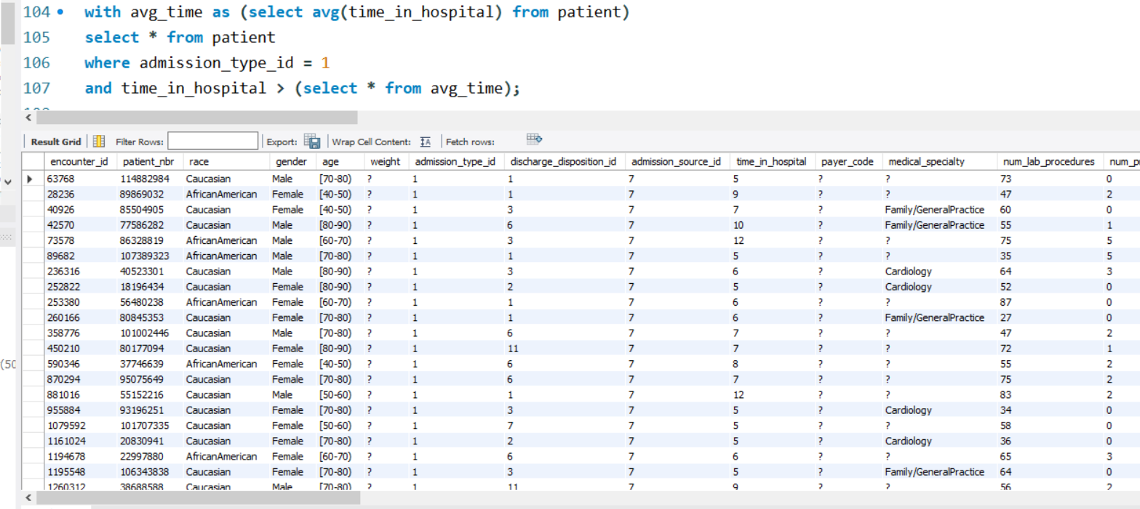

Summary:

The healthcare field is really important for society, and those in it play a crucial role in providing help when needed. This project focused on a small aspect of healthcare, and I discovered some interesting things. Most patients tend to stay in the hospital for less than 7 days, with the majority staying between two and three days. I also found out that the medical specialty with the highest average number of procedures is Surgery-Thoracic. Additionally, I learned that African Americans have the highest average number of lab procedures. What's cool is that through SQL, you can create commands that generate sentences using both data and text. This saved a lot of time because I didn't have to write out each patient's information individually, especially regarding whether they were readmitted or not.

Top of Form